Alexander Thamm: only German consultancy recognized as a service leader for data science and data engineering
Alexander Thamm GmbH [at] has been recognized by the Information Services Group (ISG) as Leader Europe in the areas of Data Science Services and Data Engineering Services in its latest Provider Lense™ Report, Quadrant 2023.
Munich, April 16, 2024 - [at] is proud to have been recognized by the Information Services Group in its latest Provider Lens™ Report. This underlines [at]'s pioneering role in Germany and Europe and reflects its many years of expertise based on more than 2,000 customer projects.
Gowtham Kumar Sampath from ISG on [at]'s strengths in the areas of data engineering and data science: "As a specialist in data engineering, Alexander Thamm optimizes companies' data infrastructure and exploits the full potential of their data to gain meaningful insights for immediate business decisions." He adds: "As part of its data science consulting, Alexander Thamm relies on white box solutions that are individually tailored to the needs of companies and create transparency. This gives them the flexibility to develop AI models independently at any time."
Make Data Work: generating added value and concrete solutions from data
European companies are facing major challenges. At the same time, the focus is on operational performance, cost reduction, and improved governance. Digital transformation is the order of the day. Companies must now engage with artificial intelligence - to optimize operational processes, make data-driven decisions faster, and develop innovative products, services, and new business models that can be translated into competitive advantages. This also requires a new innovation-centred mentality and culture in companies with the aim of generating added value based on data. This is exactly where [at] comes in together with its customers - collaboratively and at eye level.
"We are proud to be the only company in Germany to have achieved this top position. At the same time, it motivates us to continue to be a driver of innovation in the future and to continuously exceed our own standards," emphasizes Andreas Gillhuber, CO-CEO of [at]. He continues: "The award from ISG confirms our many years of AI and data science experience and our leading role in the field of data-based consulting and implementation.
Expansion and proximity to customers - [at] with a new location in Switzerland
The award also accompanies the company's further strategic expansion. With the opening of the new location in Gossau, [at] is underlining its claim to provide customers with direct and efficient local support.

Andreas Gillhuber concludes: "Our expansion into Switzerland is an important step in further building our leading position in Europe across borders and driving transformation through data and AI. We are here to stay and to accompany our customers on their data journey in the best possible way."
#makedatawork #dataengineering #datascience #ai

About Alexander Thamm
Alexander Thamm GmbH - [at] for short - is a consultancy specialized in data and artificial intelligence. [at] was founded in 2012 by Alexander Thamm and is now one of the top addresses in Europe with more than 500 employees. [at] sees itself as a partner that combines expert advice with concrete implementation. To date, [at] has implemented more than 2,000 data and AI projects. The consultancy supports numerous DAX companies and SMEs on their data journey and has offices in Munich, Berlin, Cologne, Frankfurt, Stuttgart, Leipzig, Essen, Innsbruck, Vienna, and Gossau.

Contact
Claudia Jordan
Principal Communication Manager
claudia.jordan@alexanderthamm.com

Images
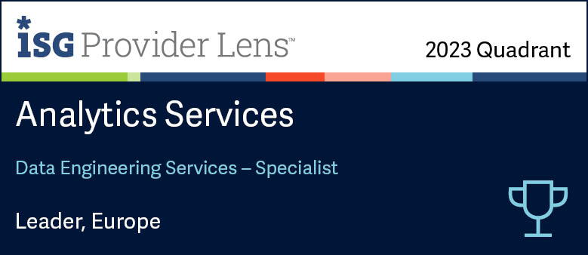
Source: ISG
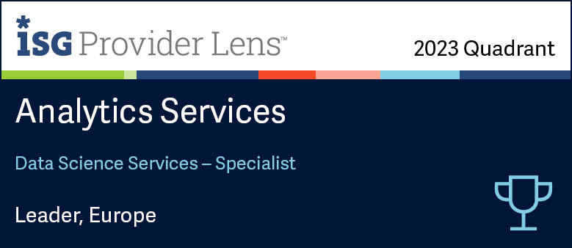
Source: ISG

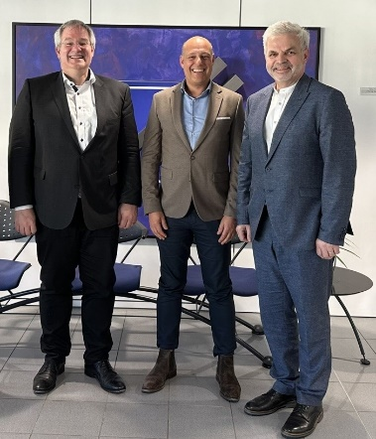
Source [at], f.l.t.r.: from [at] - Dr. Ulrich Vornefeld, Andreas Gillhuber, and Stefan Dudli. Vornefeld is CFO of Alexander Thamm GmbH and a member of the Board of Directors of Alexander Thamm Schweiz AG; Gillhuber is Co-CEO of Alexander Thamm GmbH and Chairman of the Board of Directors of Alexander Thamm Schweiz AG; Dudli is a member of the Board of Directors of Alexander Thamm Schweiz AG.

